WORKSHOP
TEMPLATES IN QUILTMAKING (incorporating quilt as you go)
BETH and TREVOR REID
This workshop explores cutting a template to be used as a repeat design and its possible variations. Design options will be explored along with the use of colour and contrast, patterned fabrics versus plain, large and small print and the use of contemporary fabrics such as batiks.
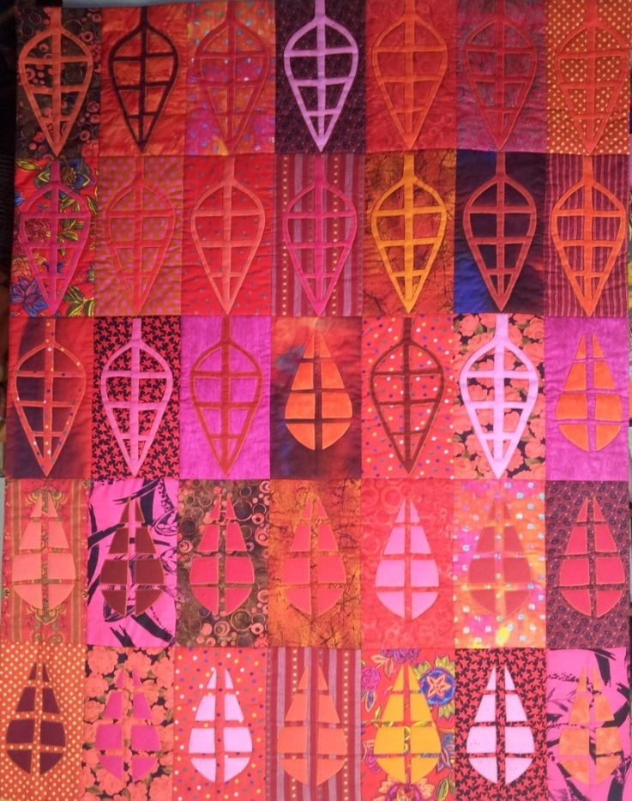
Utilising fabrics from the stash, the design can be used to construct a small quilt, wall hanging or table runner or the beginnings of a larger quilt. The top can be constructed as quilt as you go or stitched together and quilted as a whole.
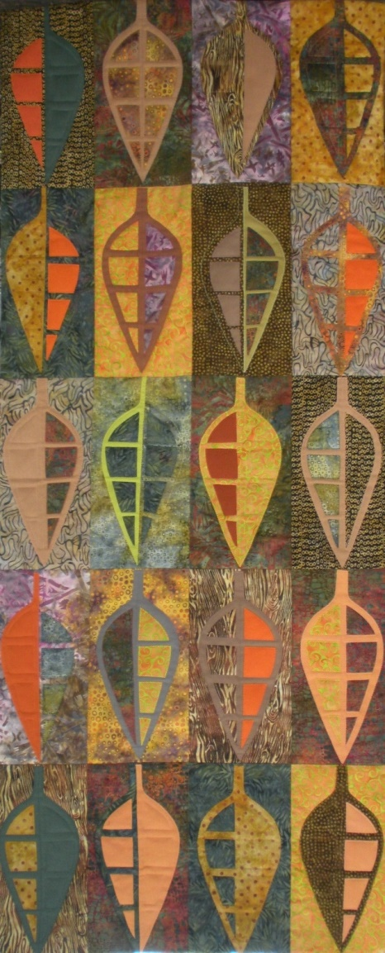

Cutting a template will be demonstrated and there will be the opportunity to design and cut your own, however, there will be templates ready made to use. You will be guided through the design process, cutting methods, and construction allowing your own creative ideas to be explored.
WHEN: Saturday, 26 and Sunday, 27 OCTOBER, 2019
WHERE: Longford War Memorial Hall, 55 Wellington Street, LONGFORD
COST: $120.00 for the two day workshop
BOOKINGS: Lesley Lyons – lesleylyons1@hotmail.com or phone 6428 3198
Margaret Treloar – mrtreloar@bigpond.com or phone 0402 440726
Full details of requirements, catering, etc., will be provided after booking.

